**Creating a PAMGuard installer**

As we’ve switched to Maven, making an installer is no longer a 1-step process. Maybe it can become that again in the future, but I wasn’t able to figure out how. So here is the 2-step method we use today.

**Preparation**

* Make sure that the version number in the pom.xml file (Overview tab) matches the info in PamguardVersionInfo.java:

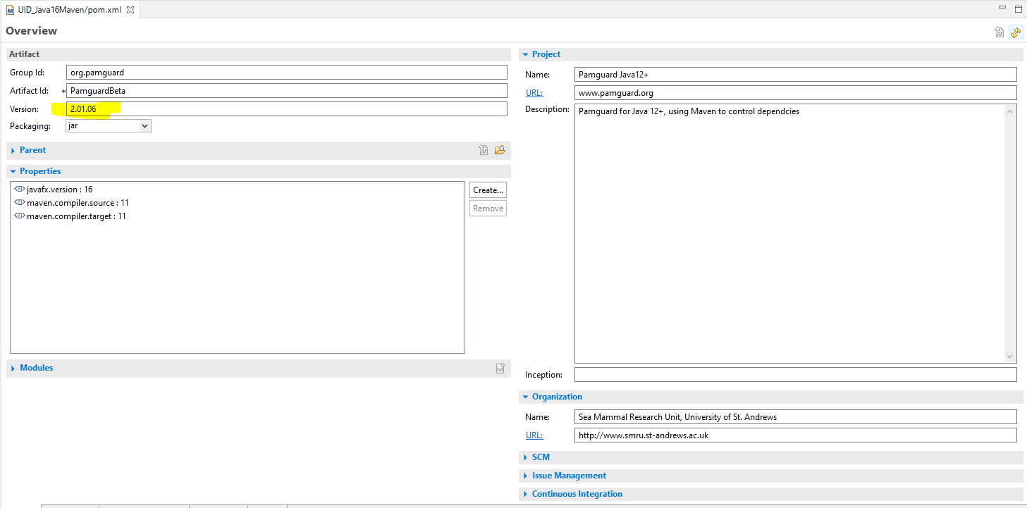

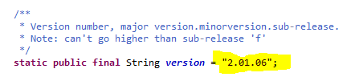

**Step 1 – Compile PAMGuard into an executable jar file.**

* You can’t simply export the project into an executable jar file anymore, because you need Maven to include the dependencies. So instead you run the Maven shade:shade configuration to do it all for you.
* Create a new Maven build configuration in Eclipse, and populate it like this:

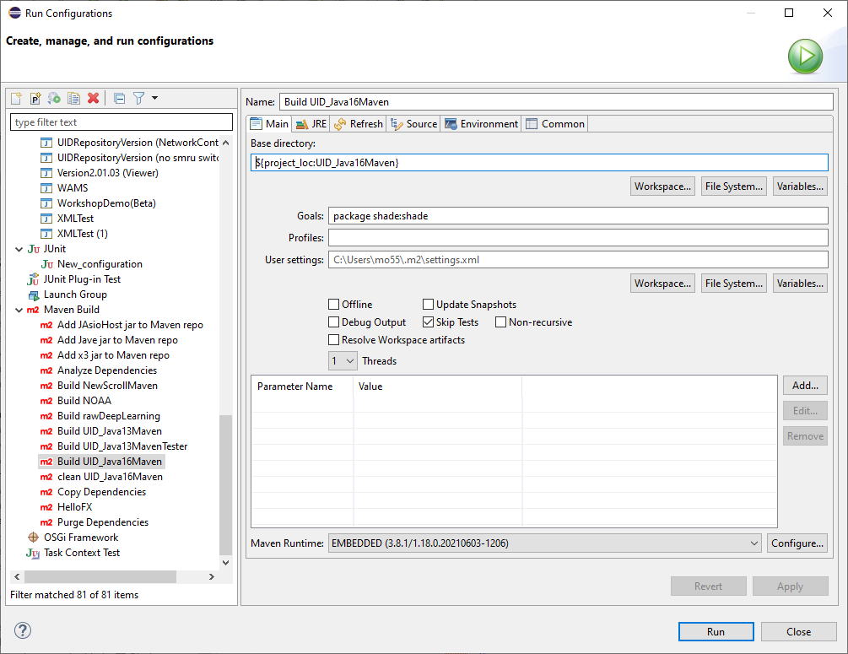

* Note that the above configuration simply runs the shade plugin – it has already been defined in the pom.xml file:

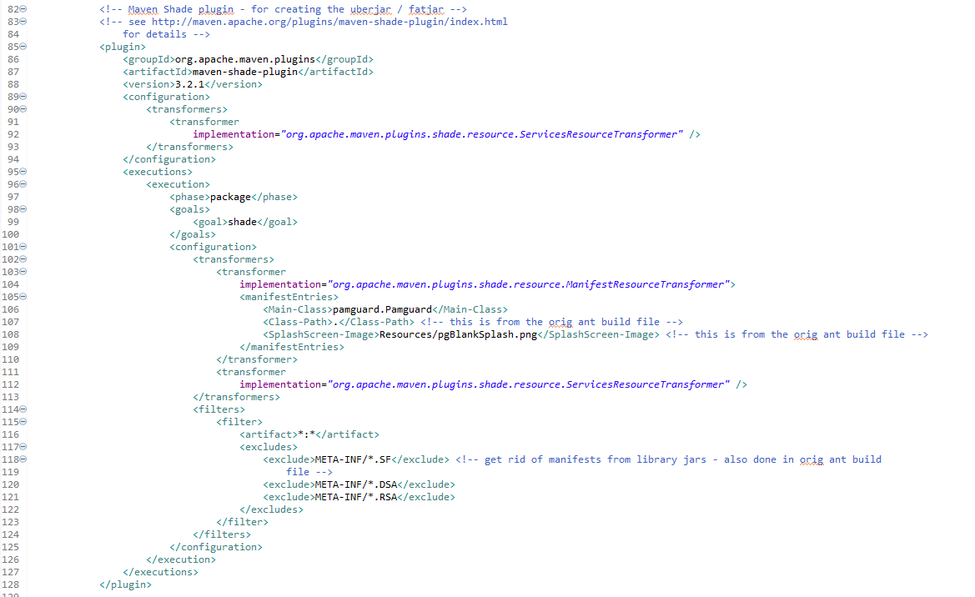

* When you run the shade build, a whole lot of text will stream through the Console window. Hopefully, in the end, it will say this:

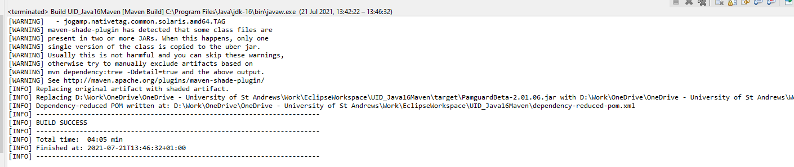

* The shade plugin will actually create 3 jar files in the target subfolder: a regular one, one with the prefix *original-*, and one with the suffix *-shaded*. As far as I can tell, these are all identical. Feel free to delete the original and shaded versions.

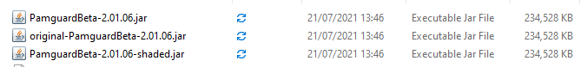

**Step 2 – Create the Installer**

* Once you have the jar file, you can create the installer package
* Make sure that the correct JRE files are found in the PamguardCompiler\Tools\JRE12Plus folder. If you’re not sure what is there (say, you’ve been switching between Java13 and Java16 and not sure what you ended with) then go into the JRE12Plus folder and open up the *release* file.
* Run PamguardCompiler:

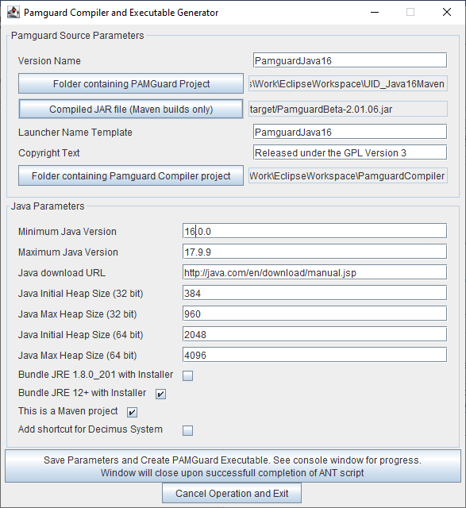

* **Version Name** is the text used for the installation folder, registry settings, windows properties, etc
* **Folder containing Project** should point to the top-level folder, where you would find the src, target, and repo subfolders
* **Compiled Jar** should point to the jar file you created in step 1 (is only enabled if this is a Maven project)
* **Launcher Name Template** is the text used for the executable and the shortcuts (-mixed and -viewer get appended to this)
* **Folder Containing PamguardCompiler** is the top level folder for the PamguardCompiler project
* **Bundle JRE12+** should be checked off, so that PamguardCompiler will bundle whatever JRE it finds in the PamguardCompiler\Tools\JRE12Plus folder into the installer package
* **This is a Maven Project** should be checked off, if this is a Maven project. If you are not compiling a Maven project, uncheck this and the Compiled Jar textbox above will be disabled. In that case, the PAMGuardCompiler will compile and package in one step
* Once all the parameters have been set, press the **Save Params and Create** button to create the installer. At one point the Windows UAC will trigger and you’ll have to enter your Username and Password to continue. This is normal.
* When complete, the new installer can be found in PamguardCompiler\Installers